MSU Extension’s Six-Step Community Change Model

Step 5: Make a Plan and Act

Step 5 Guide: Make a Plan and Act
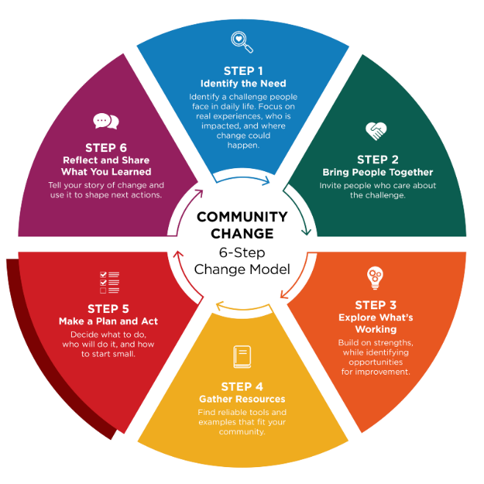
Community Champions can help activate early wins and encourage participation.

Once you know what change you want to see and decide on a goal, the next step is to create a plan to make it happen. An action plan turns ideas into concrete steps and is created by the people who care about the issue and can help move it forward. It helps to begin with the desired change and decide on a goal that feels doable, useful, and meaningful for the people involved.

Break a big goal into small, manageable steps

The purpose of an action plan is to make the work clear and realistic. Each step should:
- Describe what needs to be done
- Name who is responsible
- Include a timeline
- List what is needed for success
- Identify who needs to stay informed

A strong action plan answers questions like:
- What small steps could help us reach our goal?
- What are we going to try?
- Who is responsible for each task?
- When will changes be made?
- What help or resources do we need?
- Who needs to know about the work as it moves forward?

Considering a written policy or updating a current policy?

A written policy helps guide behavior and decisions by clearly stating expectations and procedures. It can be a useful strategy for creating and maintaining desired change. Policies can range from simple statements to more detailed documents but ultimately serve as a supportive framework. The Step 5a Worksheet provides a policy writing template and an example policy.

Keep the plan flexible

An action plan is a living tool. As the work begins, the plan should be revisited and updated. Adjusting the plan helps the change team stay focused on what is working and respond early to challenges or new opportunities.

Using the action plan during regular team check-ins supports follow-through and keeps the group moving forward.

Tip: Use regular check-ins to build momentum

Check-ins help the team stay connected, motivated, and ready to adapt. During check-ins, you can:
- Celebrate early successes
- Identify challenges or new ideas
- Adjust the plan as needed
- Discuss next steps

Step 5 Worksheet – Action Planning Template

Our Goal:

Here’s an example segment of an action plan with a goal of increasing 1-2 daily physical activities by establishing regular movement breaks into the day in an elementary school.

What action needs to be taken? | Who will be responsible? | When will this be done? | What resources are needed for success? **
Introduce the initiative, share activity ideas with teachers. | School wellness coordinator | Introduce the plan at the next staff meeting. | -The district wellness policy  -A list or menu of simple movement activities
Choose daily movement break times. | Teachers | A week before school-wide implementation | -Menu of movement activities
Implement movement breaks school wide. Coordinator visits classrooms to support implementation. | Teachers with support from coordinator | October 1 | -Posters or cards with movements
Track participation and gather feedback from teachers and students. | Coordinator | November 15 | -Digital participation tracker and simple student survey
Review progress and adjust activities as needed. | Coordinator with school leadership | December 1 | -Results of participation and student feedback

What action needs to be taken? | Who will take responsibility | When will this be done? | What resources are needed for success?
Quote: Great things are done by a series of small things brought together – Vincent Van Gogh

Early win

Can an early win be planned and used to build momentum? How will it be shared?
Possible early win: _________________________________________________________________
How will it build momentum: __________________________________________________________

Communication & check-ins

As action is taken, consistent communication with those that are involved and those that need to be aware is recommended. Consider who needs to know, how often will plan review be done, and how will progress be shared?

Communication Plan or Group Check-ins

Who needs to know? | Frequency | How shared

Step 5a Worksheet – Policy Development

A policy is simply a clear, written statement that explains what a group plans to do, how they will do it, and who it will cover. A good policy makes sure that everyone is involved and on the same page.
Writing a policy can be a very simple to very complex process, depending on the desired outcome. Below are 10 things to consider when writing a policy.

1. Policy title

A policy name can alert the reader to what and who the policy will cover.

Name of your policy: _________________________________________________________________

2. Purpose

The policy should explain how healthy eating, regular physical activity, or access to nutritious foods will be supported in the community. Consider a goal that makes it easier for people to choose and have access to healthy foods or stay active in safe, welcoming spaces.

Purpose of your policy: ______________________________________________________________________________________________________________________________________________________________________________________________________________________________________________________

3. What this policy covers

Decide what your policy applies to. Examples may include food and beverages that are provided or sold; nutrition education and messaging; or physical activity opportunities and spaces. It should also identify who the policy will affect. Consider staff, participants, visitors, or community members.

Policy coverage: ______________________________________________________________________________________________________________________________________________________________________________________________________________________________________________________

4. Key terms

Consider including key terms that need to be defined in the policy. Examples may include definitions like these:
- Healthy foods: Foods that are rich in nutrients, such as fruits, vegetables, whole grains, lean proteins, and water.
- Physical activity: Any movement that helps the body stay strong and healthy, like walking, stretching, or playing sports.
- Supportive environment: A place that is clean, safe, and makes healthy choices easy and accessible.

Key terms to include in policy: ______________________________________________________________________________________________________________________________________________________________________________________________________________________________________________________

5. Our commitments

As the policy is being written, identify what is being committed to. Examples may include:
- Offering and promoting healthy food and drink options
- Encouraging regular physical activity
- Making sure spaces are safe and welcoming for movement
- Providing clear, simple information about healthy choices
- Supporting people of all ages, abilities, and backgrounds

Commitments to include are: ______________________________________________________________________________________________________________________________________________________________________________________________________________________________________________________

6. Actions we will take (to put the policy into practice)

As a result of the policy being written, what actions need to happen and when? Below are a few suggestions that can be used:

Nutrition Supports
We will:
- Provide healthy food and drink options at events, meetings, and programs
- Limit sugary drinks and less healthy snacks
- Make water available and accessible at all times
- Share easy-to-understand nutrition information
- Support breastfeeding and safe infant-feeding practices (if relevant)
- Establish a salad bar in our cafeteria

Physical Activity Supports
We will:
- Provide safe indoor or outdoor spaces for movement
- Encourage activity breaks during long meetings or programs
- Offer or promote walking groups, fitness classes, or active play
- Make sure activities are inclusive and accessible for all abilities
- Promote active transportation when possible (walking, biking)
- Make the school playground available for use during afterschool hours

Policy actions to take will be: ______________________________________________________________________________________________________________________________________________________________________________________________________________________________________________________

7. Roles and responsibilities

As the policy is being developed, it is important to determine who will be responsible for what actions. Here are a few examples to consider:
- Leadership: Makes sure the policy is followed and provides resources
- Staff: Models healthy behaviors, supports activities, and reports concerns
- Participants/Community Members: Use spaces responsibly and share feedback

Who are the people and what are the responsibilities to make the policy successful? ______________________________________________________________________________________________________________________________________________________________________________________________________________________________________________________

8. Reporting concerns

Once a policy is written, determine what options are available for people to report their concerns.

Outline who can report a concern about the food, beverage, or physical activity spaces. For example, include how reports can be made and how they will be resolved:
- Speaking with a staff member
- Calling the main office
- Using the online or written reporting form

We will review concerns promptly and take action. How will concerns be handled: ______________________________________________________________________________________________________________________________________________________________________________________________________________________________________________________

9. Monitoring and success tracking

Once the policy is written, it will be important that it is reviewed regularly and updated if warranted. Include how this will be done. An example is:

We will regularly:
- Review the types of foods and drinks offered
- Check the condition and safety of activity spaces
- Ask for feedback from staff and participants
- Update this policy as needed

The policy will be reviewed and evaluated in the following way: ______________________________________________________________________________________________________________________________________________________________________________________________________________________________________________________

10. Communication

Informing staff, volunteers, and community members is important to show the investment being made, through the policy, in the health of the community. A simple statement will let the community know what to expect. Consider a statement like “We will share this policy with staff, participants, and community members. Updates will be posted in common areas and on our website.”
Policy communication plan: ______________________________________________________________________________________________________________________________________________________________________________________________________________________________________________________

Below is an example policy. Look for the various components mentioned above.

Policy example: A workplace writes a policy that supports adequate time and location for employees to breastfeed and/or pump at work.

ELG Factory Lactation Accommodation Policy
The ELG Factory is a breastfeeding-supportive employer. In accordance with the Federal PUMP for Nursing Mothers Act and the Michigan Breastfeeding Antidiscrimination Act, this company provides reasonable breaktime and appropriate accommodation for employees who need to express breastmilk during the workday. Employees may access these accommodations for as long as they choose to breastfeed or express milk.

All employees at the ELG Factory will:
- Be provided with a place to breastfeed or express their milk in a private space that is not a bathroom. It will be clean, functional for pumping, and shielded from view.
- Have an available refrigerator space to safely store their expressed breastmilk.
- Be provided with flexible breaks to accommodate breastfeeding or milk expression.

This policy will be applied to all employees who need this accommodation and will be implemented and enforced by shift supervisors and human resources staff. Supervisors are responsible for ensuring all their breastfeeding employees have access to these accommodations.

This policy will be reviewed annually by the ELG Health and Wellness Committee at the beginning of every year to ensure ongoing compliance with federal, state, and local laws. This policy is published in the employee manual and will be communicated to all employees in the annual employee update email. This policy information will also be provided to new employees during their onboarding. This policy will be communicated to all shift supervisors during the first staff meeting every year to maintain a supportive work environment for breastfeeding employees.

This policy was last reviewed and updated in March 2026.

Reflection

- Are there any important steps missing from the plan to make it work?
- Will the plan likely lead to the desired change?
- Connecting the dots, will the change meet your identified need?

About MSU Extension’s Community Change Model
This Guide and Worksheet is part of a larger Six-Step Community Change Model Toolkit that assists community champions in supporting communities to make thoughtful, lasting improvements that help people choose nourishing foods and stay active. Six simple steps guide desired change efforts by bringing people together, taking action, and sharing what was learned along the way.
See MSU Extension’s Community Change Hub for curated resources and topic-specific guidance that support change efforts related to championing school wellness, food access, early childhood health, and active communities.

